**Project Increment-1**

**Team members**

Oshani Titti (12443220)

Ram Shasank Pathath (16183838)

Mohan Krishna Doddala (16201768)

**Design**

We mainly focused on implementing at least one feature in each basic requirement.

Sensor-based Robot Control ( Plays audio file)

Sensor-based Simple Speech Out (Image recognition – color detection).

Sensor-based Movement (Uses camera to detect the red color and then stops its movement)

Simple Peer-to-Peer Collaboration (Robot-to-Mobile using socket programming)

**Features**

The features that we have implemented are

* Peer-to-Peer Movement (phone-to-phone)

We have implemented this feature using socket programming. You can control the operations of Robo me by using an android device. The input from the android device can be given in two way:

* You can select the operations from the displayed screen.
* You can give a voice input (like Forward, Backward, Up, Down)
* Actions

When you say sing it will play an audio file until you say stop.

* Traffic Signs

When it sees a red color or a stop sign, it will recognize the color and immediately stop.

* Translation API

We have tried to integrate the implementation of REST service by using Microsoft Translation API which is helpful in translating 51 different languages into English. We could not complete the integration part perfectly.

**Screenshots**

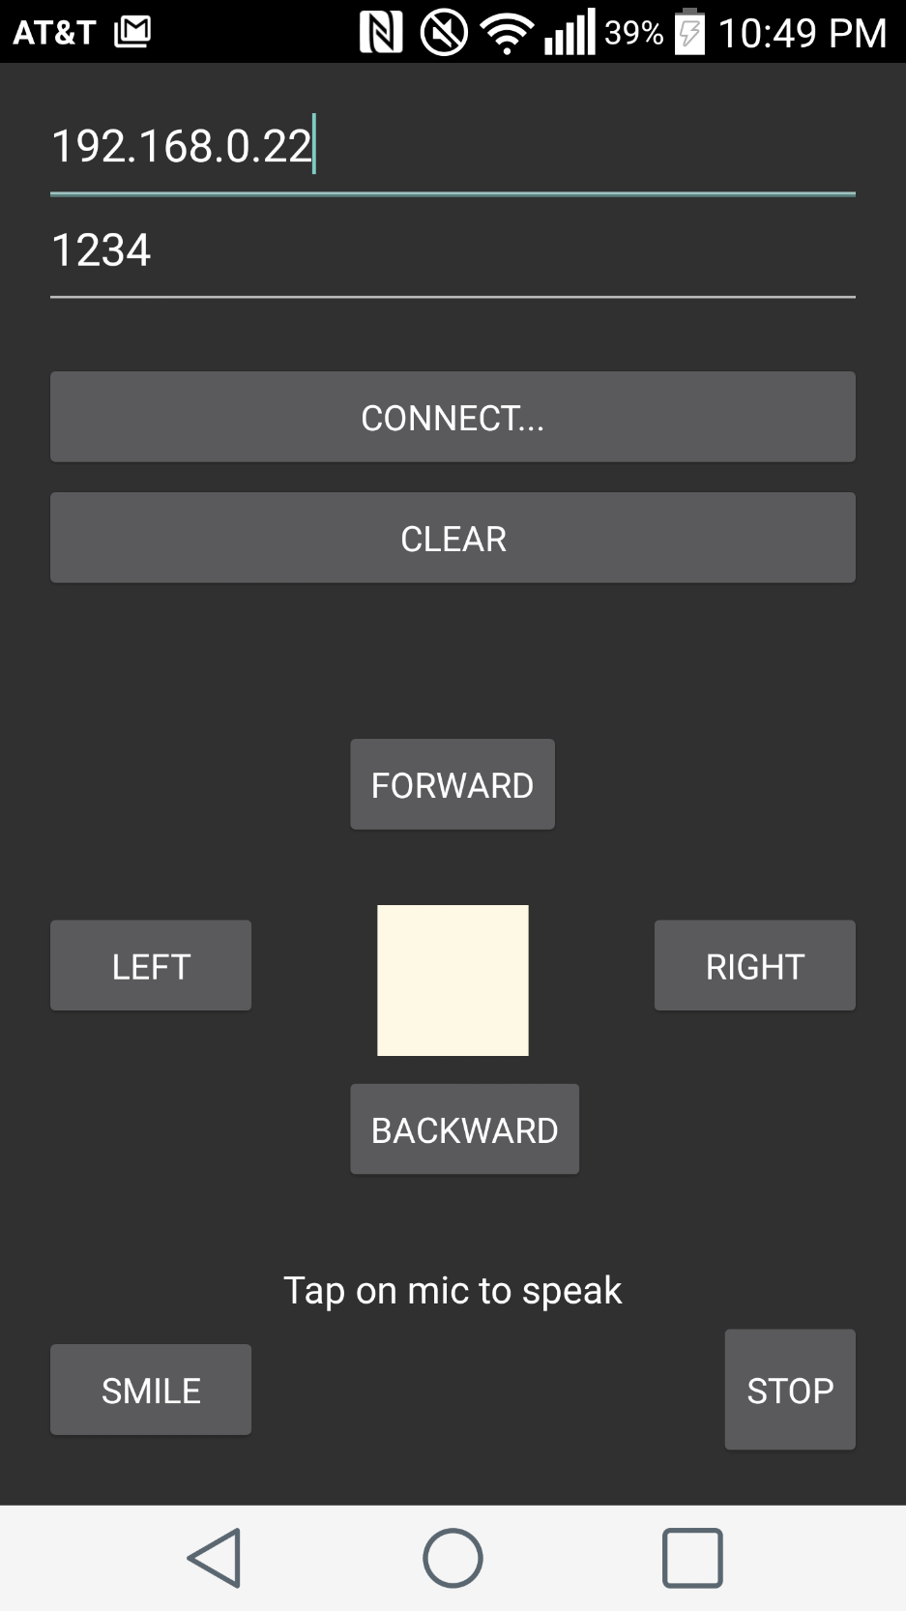

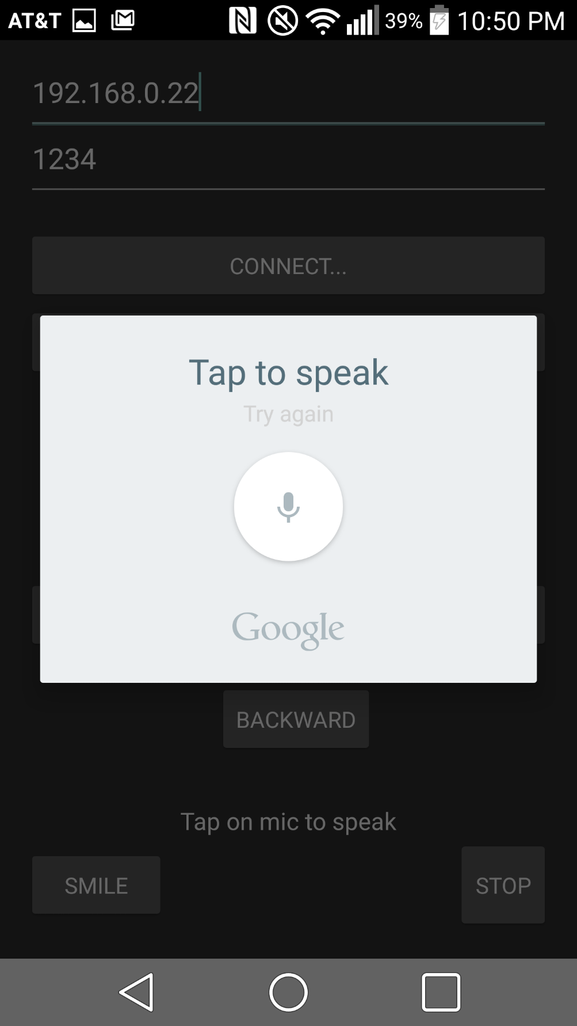

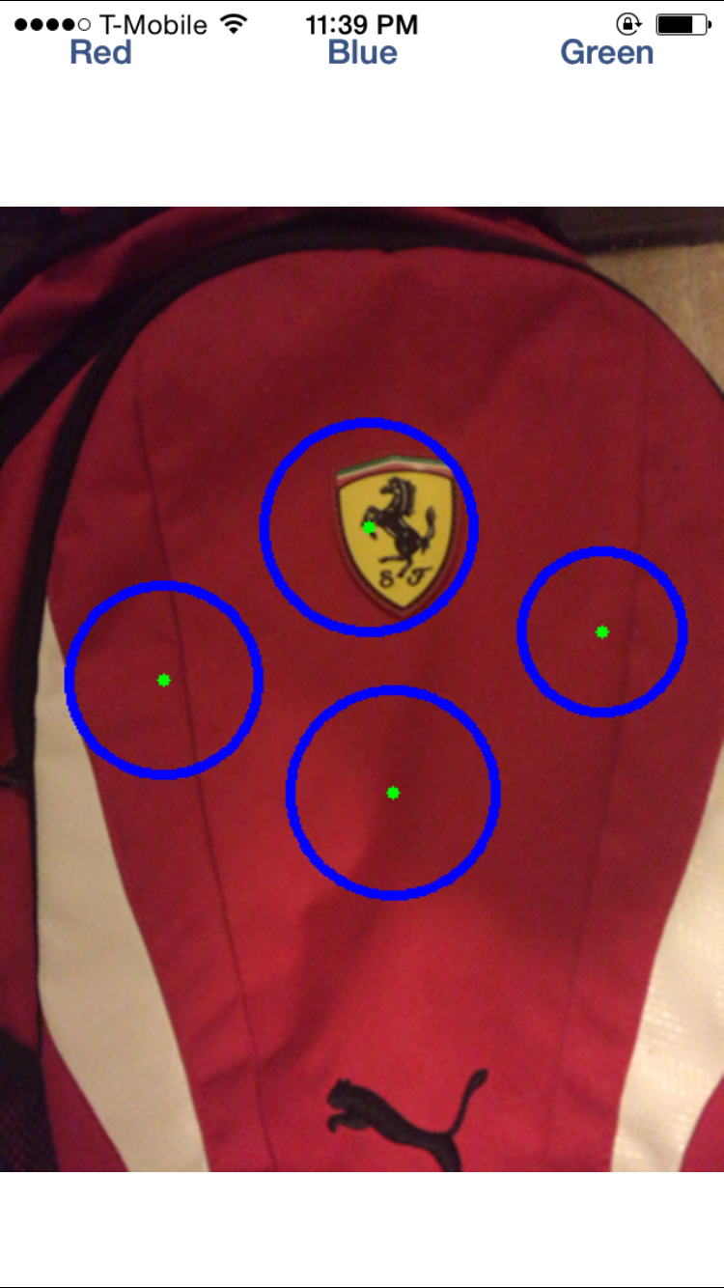

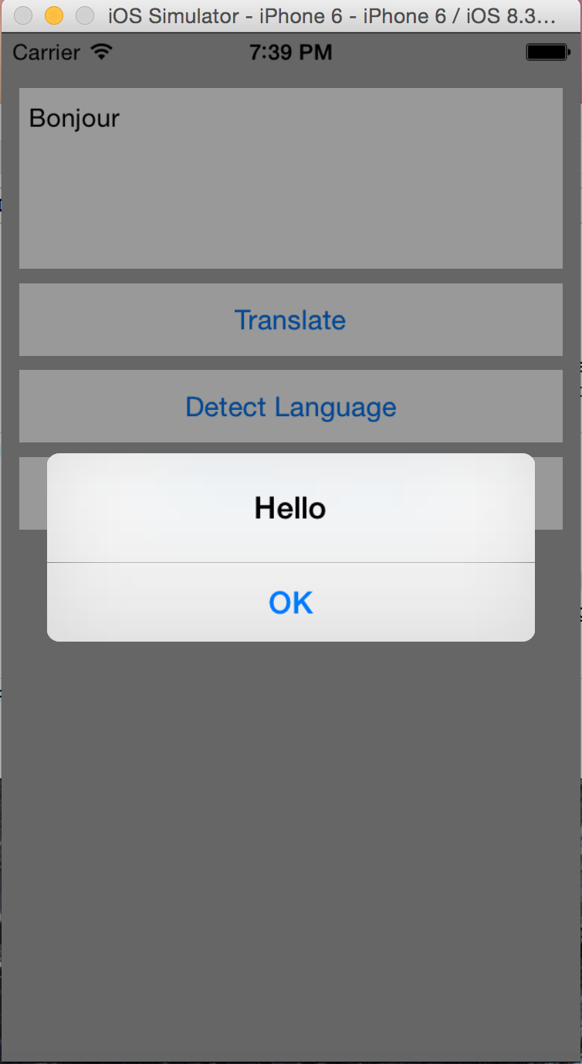

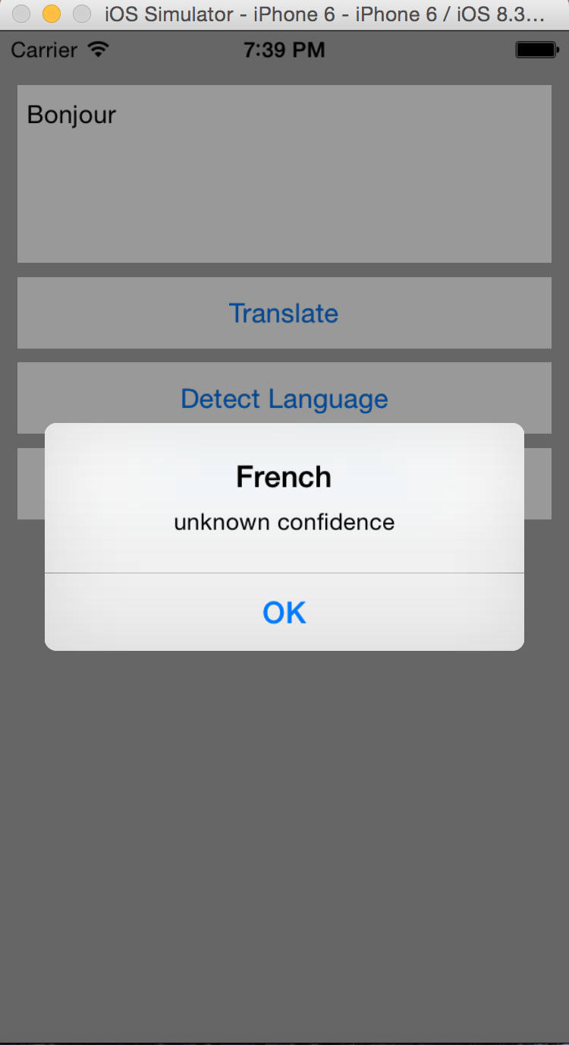

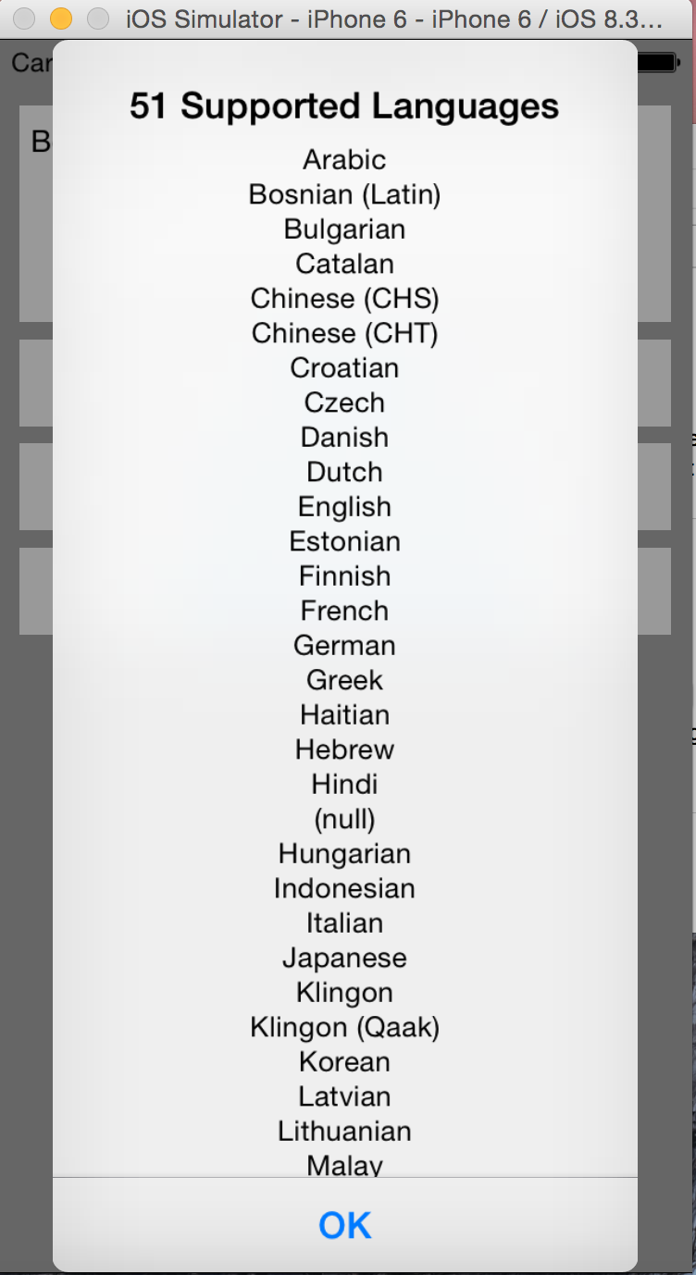

**Resources**

<http://stackoverflow.com/questions/11716244/how-to-play-a-music-file-using-url-link-in-iphone>

<http://stackoverflow.com/questions/15850447/how-to-get-audio-to-play-from-an-online-url-on-iphone>

<http://stackoverflow.com/questions/6101286/making-a-button-call-a-phone-number-in-ios>

<http://stackoverflow.com/questions/9362785/how-to-automatically-take-a-picture-without-pressing-the-phototaken-button-on-th>

<http://stackoverflow.com/questions/4929717/make-a-phone-call-programmatically>

Github

<https://github.com/ramshasank/projectinc1>